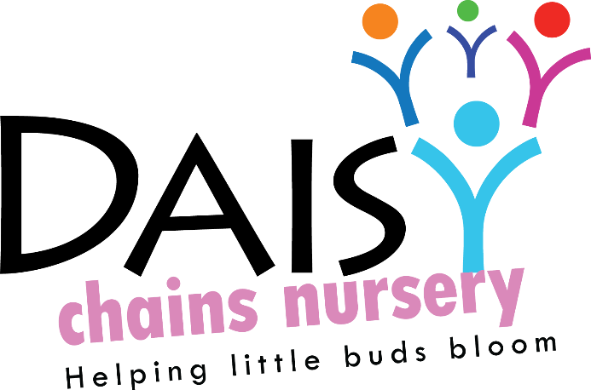
Daisy Chains Nursery,
South Ashford Youth Centre,
St Stephens Walk,
Ashford,
Kent,
TN23 5BD

Administration and Admissions
Policy statement
It is our intention to make our setting accessible to children and families from all sections of the local community. We aim to ensure that all sections of our community have access to the setting through open, fair and clearly communicated procedures.

Procedures
- We ensure that the existence of our setting is widely advertised in places accessible to all sections of the community.
- We ensure that information about our setting is accessible, in written and spoken form and, where appropriate, in more than one language. We will provide translated written materials where language needs of families suggest this is required as well as offering a family member as a translator.
- We arrange our waiting list forms on first come first basis. On entry parents will be required to fill out a registration pack and provide a copy of the child’s birth certificate, copies of the birth certificate will not be kept on file, the reference number will be noted down on the registration form.
- We describe our setting and its practices in terms that make it clear that it welcomes fathers and mothers, other relations and other carers, including childminders. All permissions must be signed by primary carers.
- We describe our setting and its practices in terms of how it treats each child and their family, having regard to their needs arising from their gender, special educational needs, disabilities, social background, religion, ethnicity, sexuality or with English as an additional language.
- We endeavour to cater for all disabilities and we will aim to accommodate children and their families within the means of our provision, with the child’s wellbeing as paramount.
- We make our Valuing Diversity and Promoting Equality Policy widely known.
- We consult with families about the opening times of the setting to ensure we accommodate a broad range of family need.
- We are flexible about attendance patterns to accommodate the needs of individual children and families, providing these do not disrupt the pattern of continuity in the setting that provides stability for all the children.
- Transfer of funding will be made in line with Kent County Council guidelines.

Admissions
In no particular order the following criteria is taken into account when offering places within our settings and our waiting lists are arranged and prioritised accordingly: First come first served. Proof of eligibility for free for 2 funding will need to be provided prior to confirming registration, 30 hour codes must be applied for by the relevant government deadline, proof must be sent to the nursery before the beginning of the term along with a copy of childs birth certificate a fully completed registration pack and any relevant deposit.

Fees and Pricing Policy
Aim:
To ensure that parents and prospective parents are aware of and understand the methods by which fees can be paid.
Fees structure will increase in accordance with National Minimum Wage Increase every April.
To make parents aware of the timescales required when paying their accounts, and the procedures of fee collection.

Deposits
- Private fee payers will have to deposit up to 4 weeks of fees in advance to their start date. This will be deducted off their final invoice when leaving the nursery. A notice of two weeks must be received in writing.
- To secure a 3-4 year funded only place a deposit of £50 must be paid to the nursery. This will be returned within 6 weeks of the child beginning their term at nursery. Or this can be used against any other service provided by the setting or used to purchase a lifetime licence of Sparkpro at home.

Payment Methods:
We recognise that the cost of registered childcare may seem expensive to a parent/carer. However, providing a high quality, safe and stimulating service for children is expensive and to ensure the continued high standards and sustainability of the service we must ask that parents/carers respect our policy in relation to fees.
● Fees are payable one month in advance.
Invoices will be issued on 25th of the month, which are then payable on the 1st of each month
● Payments are accepted and preferred by the BACS system. We do take payments via our SUMUP card machine for payments, additional charges may apply when using this service.

Late Payments:
Fees are payable in advance and expected to be paid on the first of the month. A reminder via email will be given after 7 days with a statement of account including any added interest. If payment is still not received within 7 days then the nursery reserve the right to suspend any paid for service that is contained within the invoice. These services will be reinstated once outstanding payments are made.
If fees are not paid by the required date, the nursery reserves the right to charge interest at the rate of 3% per week on all outstanding fees.
We value partnership working and if at any time you are experiencing financial difficulty, please discuss with Management, who may consider alterative payment options before it is necessary to use the above steps.

Free Entitlement:
For children claiming the government 3 and 4 year old nursery education grant, if your child attends more than 15 hours then you will be invoiced for your additional hours.
For children claiming the government free for two nursery education grant, if your child attends more than 15 hours then you invoiced for your additional hours.
If you wish to attend just your 15 free entitlement hours then you may do so without additional charges.
For children claiming 30 hour free entitlement hours you are able to do so without additional charges.
Optional extras such as, breakfast, hot lunches, sport session and uniform will be charged.
For all children receiving the government nursery education grant, a parent’s declaration form is to be completed each term.

Absence and Holidays:
Fees are payable when children are absent or on holiday.
If your child has been admitted into hospital then fees will not be charged, as long as proof of admission is provided on their return to the setting.

Pricing:
We endeavour to keep our fees competitive with other providers in our local area, as well as be affordable for our local community.
We have a set price list which is available to parents and included with this policy.
Fees are reviewed annually, this is reflecting the increase in the NMW, parents will be notified of any changes in writing.

Price List:
Sessions: £18 per session (2 year old)
£15 per session (3 year old)
All day: £36 per day (2 year old)
£30 per day (3 year old)

Late fee cost after 15mins: £5 and then an additional £1 for every minute after
Date to be reviewed: 5TH May 2020

Signed on behalf of the management:
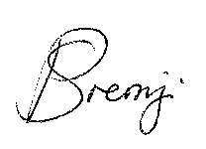
Name of signatory: Sajedah Mohamedali

Role of signatory (e.g. owner): Director

