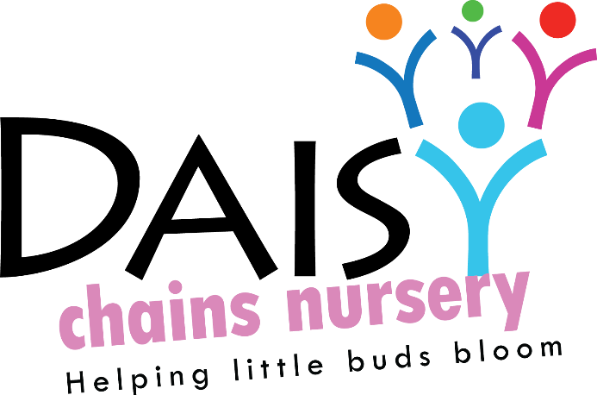
Daisy Chains Nursery,
South Ashford Youth Centre,
St Stephens Walk,
Ashford,
Kent,
TN23 5BD

Employment

Induction of staff, volunteers and managers

Policy statement

We provide an induction for all staff, volunteers and managers in order to fully brief them about the setting, the families we serve, our policies and procedures, curriculum and daily practice.

Procedures

- We have a written induction plan for all new staff, which includes the following:
- Introductions to all staff and volunteers, including management committee members.
- Familiarising with the building, health and safety and fire procedures.
- Ensuring our policies and procedures have been read and are carried out.
- Introduction to parents, especially parents of allocated key children where appropriate.
- Familiarising them with confidential information where applicable in relation to any key children.
- Details of the tasks and daily routines to be completed.
- The induction period lasts two weeks. The manager inducts new staff and volunteers. The chairperson or senior manager inducts new managers.
- During the induction period, the individual must demonstrate understanding of and compliance with policies, procedures, tasks and routines.
- Successful completion of the induction forms part of the probationary period.

This policy was adopted at a meeting:

Held on: 24/08/20

Date to be reviewed: August 2021

Signed on behalf of the management: J Sutton

Name of signatory: James Sutton

Role of signatory (e.g. owner): manager

