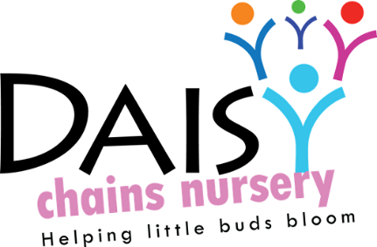
Daisy Chains Nursery
South Ashford Youth Centre
St Stephens Walk
Ashford
Kent
TN23 5BD

Promoting health and hygiene

Managing children with allergies, or who are sick or infectious
(Including reporting notifiable diseases)

Policy statement

We provide care for healthy children and promote health through identifying allergies and preventing contact with the allergenic substance and through preventing cross infection of viruses and bacterial infections.

Procedures for children with allergies

- When parents start their children at the setting they are asked if their child suffers from any known allergies. This is recorded on the registration form.
- If a child has an allergy, a risk assessment form is completed to detail the following:
- The allergen (i.e. the substance, material or living creature the child is allergic to such as nuts, eggs, bee stings, cats etc).
- The nature of the allergic reactions e.g. anaphylactic shock reaction, including rash, reddening of skin, swelling, breathing problems etc.
- What to do in case of allergic reactions, any medication used and how it is to be used (e.g. Epipen).
- Control measures – such as how the child can be prevented from contact with the allergen.
- Review.
- This form is kept in the child’s personal file and a copy is displayed where staff can see it.
- Parents train staff in how to administer special medication in the event of an allergic reaction.

Insurance requirements for children with allergies and disabilities
- The insurance will automatically include children with any disability or allergy but certain procedures must be strictly adhered to as set out below. For children suffering life threatening conditions, or requiring invasive treatments; written confirmation from your insurance provider must be obtained to extend the insurance.

At all times the administration of medication must be compliant with the Welfare Requirements of the Early Years Foundation Stage and follow procedures based on advice given in Managing Medicines in Schools and Early Years Settings (DfES 2005)

Oral medication
Asthma inhalers are now regarded as "oral medication" by insurers and so documents do not need to be forwarded to your insurance provider.
- Oral medications must be prescribed by a GP or have manufacturer’s instructions clearly written on them.
- The group must be provided with clear written instructions on how to administer such medication.
- All risk assessment procedures need to be adhered to for the correct storage and administration of the medication.
- The group must have the parents or guardians prior written consent. This consent must be kept on file. It is not necessary to forward copy documents to your insurance provider.

Life saving medication & invasive treatments
Adrenaline injections (Epipens) for anaphylactic shock reactions (caused by allergies to nuts, eggs etc)
The setting must have:
- a letter from the child's GP/consultant stating the child's condition and what medication if any is to be administered;
- written consent from the parent or guardian allowing staff to administer medication; and
- proof of training in the administration of such medication by the child's GP, a district nurse, children’s’ nurse specialist or a community paediatric nurse.

Key person for special needs children - children requiring help with tubes to help them with everyday living e.g. breathing apparatus, to take nourishment, colostomy bags etc.
- Prior written consent from the child's parent or guardian to give treatment and/or medication prescribed by the child's GP.
- Key person to have the relevant medical training/experience, which may include those who have received appropriate instructions from parents or guardians, or who have qualifications.

This policy was adopted at a meeting:

Held on:24/08/20

Date to be reviewed: August 2021

Signed on behalf of the management: J Sutton

Name of signatory: James Sutton

Role of signatory (e.g. owner): manager

