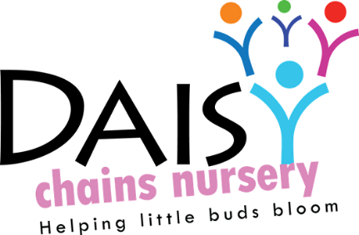
Daisy Chains Nursery
South Ashford Youth Centre
St Stephens Walk
Ashford
Kent
TN23 5BD

Promoting health and hygiene

No-smoking
This is a statutory policy Purpose This policy has been developed to protect all employees, service users, customers and visitors from exposure to secondhand smoke and to assist compliance with the Health Act 2006.
Exposure to secondhand smoke increases the risk of lung cancer, heart disease and other serious illnesses. Ventilation or separating smokers and non-smokers within the same airspace does not completely stop potentially dangerous exposure. It is the policy of Daisy Chains Nursery that all our workplaces are smoke free, and all employees have a right to work in a smoke free environment. The policy came into effect on Sunday 1 July 2007. Smoking is prohibited in all enclosed and substantially enclosed premises in the workplace. This includes company vehicles.
This policy applies to all employees, consultants, contractors, customers or members and visitors. Overall responsibility for policy implementation and review rests with the designated person James Sutton and Deputy Manager Toni Jones. However, all staff are obliged to adhere to, and support the implementation of the policy. The persons named above shall inform all existing (and new) employees / helpers / visitors of the policy and their role in the implementation and monitoring of the policy. They will also give all new personnel a copy of the policy on recruitment / induction.
Appropriate ‘no-smoking’ signs will be clearly displayed at the entrances to and within the premises, and in all smoke free vehicles.
Noncompliance:
Local disciplinary procedures will be followed if a member of staff does not comply with this policy. Those who do not comply with the smoke free law may also be liable to a fixed penalty fine and possible criminal prosecution.

No Smoking Statement
Daisy Chains Nursery recognize that a person has the right to be protected from the harm of secondhand smoke and to breathe smoke free air. We therefore have a no- smoking policy, both for staff and visitors.
However, we also recognize that staff, crèche workers or students on duty or placement may feel that they have a right to smoke in their own time. Those who wish to smoke are required to walk off site. They are only able to do this within their own breaks and therefore in their own time. All staff are to ensure that they wear clothing that covers the company uniform when smoking so that it is not visible to members of the public.
Once back in the sessions, they are reminded that hands should be washed prior to working with the children, to ensure that traces of nicotine are not transferred to the children or their clothes.
Smokers are requested that cigarette ends are disposed of carefully (and not thrown onto the ground) and must ensure that all cigarettes are extinguished fully before disposal. This policy also applies to any form of vaping and the same procedures need to be adhered to.

This policy was adopted at a meeting:

Held on: 24/08/20

Date to be reviewed: August 2020

Signed on behalf of the management: J Sutton

Name of signatory: James Sutton

Role of signatory (e.g. owner): manager

