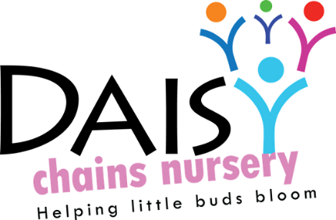
Daisy Chains Nursery
South Ashford Youth Centre
St Stephens Walk
Ashford
Kent
TN23 5BD

Safeguarding children

Supervision of children on outings and visits

Policy statement

Children benefit from being taken out of the setting to go on visits or trips to local parks or other suitable venues for activities which enhance their learning experiences. Some settings do not have direct access to outdoor provision on their premises and will need to take children out daily. Staff in our setting ensure that there are procedures to keep children safe on outings; all staff and volunteers are aware of and follow the procedures below.

Procedures

- Parents sign a general consent on registration for their children to be taken out as a part of the daily activities of the setting.
- This general consent details the venues used for daily activities.
- A risk assessment for each venue is carried out, which is reviewed regularly.
- Parents are always asked to sign specific consent forms before major outings.
- A risk assessment is carried out before an outing takes place.
- All venue risk assessments are made available for parents to see.
- Our adult to child ratio is considered, all children will be transported using a ratio of 1:5 as a maximum and only within close proximity to the settin.
- Named children are assigned to individual staff to ensure each child is individually supervised, to ensure no child goes astray, and that there is no unauthorised access to children.
- Staff take a mobile phone on outings, and supplies of tissues, wipes, pants etc as well as a mini first aid pack, snacks and water. The amount of equipment will vary and be consistent with the venue and the number of children as well as how long they will be out for.
- Staff take a list of children with them with contact numbers of parents/carers.
- A minimum of two staff should accompany children on outings and a minimum of two should remain behind with the rest of the children.
- If the outing to be planned will consist of venturing further away from the setting then the ratio will be raised to 1:2 to ensure the safety and wellbeing of all children at all times.

This policy was adopted at a meeting:

Held on: 24/08/20

Date to be reviewed: August 2021

Signed on behalf of the management: J Sutton

Name of signatory: James Sutton

Role of signatory (e.g. owner): manager

