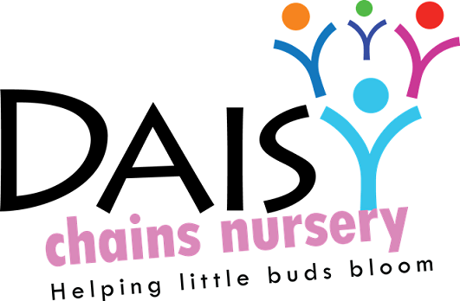
Daisy Chains Nursery
South Ashford Youth Centre
St Stephens Walk
Ashford
Kent
TN23 5BD

Record keeping

Provider records

Policy statement

We keep records for the purpose of maintaining our business. These include:
- Records pertaining to our registration.
- Landlord/lease documents and other contractual documentation pertaining to amenities, services and goods.
- Financial records pertaining to income and expenditure.
- Risk assessments.
- Employment records of staff.

Our records are regarded as confidential on the basis of sensitivity of information, such as with regard to employment records and these are maintained with regard to the framework of the Data Protection Act and the Human Rights Act.

This policy and procedure is taken in conjunction with the Confidentiality and Client Access to Records policy and Information Sharing policy.

Procedures

- All records are the responsibility of the officers of the management committee who ensure they are kept securely.
- All records are kept in an orderly way in files and filing is kept up-to-date.
- Financial records are kept up-to-date for audit purposes.
- Health and safety records are maintained; these include risk assessments, details of checks or inspections and guidance etc.
- Our Ofsted registration certificate is displayed.
- Our Public Liability insurance certificate is displayed.
- All our employment and staff records are kept securely and confidentially.

This policy was adopted at a meeting:

Held on: 24/08/20

Date to be reviewed: August 2021

Signed on behalf of the management: J Sutton

Name of signatory: James Sutton

Role of signatory (e.g. owner): manager

