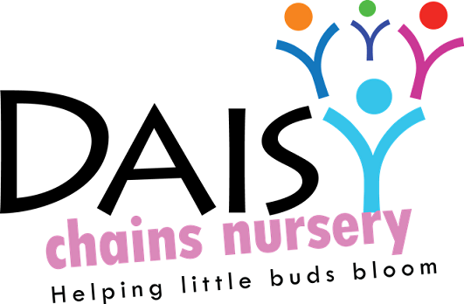
Daisy Chains Nursery
South Ashford Youth Centre
St Stephens Walk
Ashford
Kent
TN23 5BD

Health and safety

Recording and reporting of accidents and incidents
(Including procedure for reporting to HSE, RIDDOR)

Policy statement

We follow the guidelines of the Reporting Injuries, Diseases and Dangerous Occurrences (RIDDOR) for the reporting of accidents and incidents. Child protection matters or behavioural incidents between children are NOT regarded as incidents and there are separate procedures for this.

Procedures

Our accident book:
- is kept safely and accessibly through our Eylog system;
- is accessible to all staff and volunteers, who know how to complete it; and
- is reviewed at least half termly to identify any potential or actual hazards.

Ofsted is notified of any injury requiring treatment by a general practitioner or hospital doctor, or the death of a child or adult.

When there is any injury requiring general practitioner or hospital treatment to a child, parent, volunteer or visitor or where there is a death of a child or adult on the premises, we make a report to the Health and Safety Executive using the format for the Reporting of Injuries, Diseases and Dangerous Occurrences.

Dealing with incidents
We meet our legal requirements for the safety of our employees by complying with RIDDOR (the Reporting of Injury, Disease and Dangerous Occurrences Regulations). We report to the Health and Safety Executive:
- any accident to a member of staff requiring treatment by a general practitioner or hospital; and
- any dangerous occurrences. This may be an event that causes injury or fatalities or an event that does not cause an accident but could have done, such as a gas leak.
- Any dangerous occurrence is recorded in our incident book. See below.

Our incident book
- We have ready access to telephone numbers for emergency services, including local police. Where we are responsible for the premises we have contact numbers for gas and electricity emergency services, carpenter and plumber. Where we rent premises we ensure we have access to the person responsible and that there is a shared procedure for dealing with emergencies.
- We keep an incident book for recording incidents including those that that are reportable to the Health and Safety Executive as above.
- These incidents include:
- break in, burglary, theft of personal or the setting's property;
- an intruder gaining unauthorised access to the premises;
- fire, flood, gas leak or electrical failure;
- attack on member of staff or parent on the premises or nearby;
- any racist incident involving staff or family on the centre's premises;
- death of a child, and
- a terrorist attack, or threat of one.
- In the incident book we record the date and time of the incident, nature of the event, who was affected, what was done about it - or if it was reported to the police, and if so a crime number. Any follow up, or insurance claim made, should also be recorded.
- In the unlikely event of a terrorist attack we follow the advice of the emergency services with regard to evacuation, medical aid and contacting children's families. Our standard Fire Safety Policy will be followed and staff will take charge of their key children. The incident is recorded when the threat is averted.
- In the unlikely event of a child dying on the premises, for example, through cot death in the case of a baby, or any other means involving an older child, the emergency services are called, and the advice of these services are followed.
- The incident book is not for recording issues of concern involving a child. This is recorded in the child's own file.

Legal framework

- Reporting of Injuries, Diseases and Dangerous Occurrences Regulations (RIDDOR 1995)
Further guidance

- RIDDOR Guidance and Reporting Form
This statement was adopted at a meeting:

Held on: 24/08/20

Date to be reviewed: August 2021

Signed on behalf of the management: J Sutton

Name of signatory: James Sutton

Role of signatory (e.g. owner): manager

