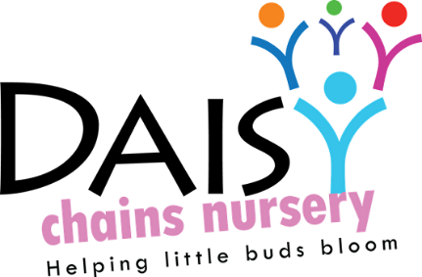
Daisy Chains Nursery
South Ashford Youth Centre
St Stephens Walk
Ashford
Kent
TN23 5BD

Equality of opportunity

Supporting children with special educational needs

Policy statement

We provide an environment in which all children, including those with special educational needs, are supported to reach their full potential.

- We have regard for the DfES Special Educational Needs and Disabilities Code of Practice (2015).
- We ensure our provision is inclusive to all children with special educational needs.
- We support parents and children with special educational needs (SEN).
- We identify the specific needs of children with special educational needs and meet those needs through a range of SEN strategies.
- We work in partnership with parents and other agencies in meeting individual children's needs.
- We monitor and review our policy, practice and provision and, if necessary, make adjustments.

Procedures

- We designate a member of staff to be the Special Educational Needs Co-ordinator (SENCO) and give his/her name to parents. Our SENCO is
James Sutton (manager)
- We ensure that the provision for children with special educational needs is the responsibility of all members of the setting.
- We ensure that our inclusive admissions practice ensures equality of access and opportunity.
- We use the graduated response system for identifying, assessing and responding to children's special educational needs.
- We work closely with parents of children with special educational needs to create and maintain a positive partnership.
- We ensure that parents are informed at all stages of the assessment, planning, provision and review of their children's education.
- We provide parents with information on sources of independent advice and support.
- We liaise with other professionals involved with children with special educational needs and their families, including transfer arrangements to other settings and schools.
- We provide a broad, balanced and differentiated curriculum for all children with special educational needs.
- We use a system of planning, implementing, monitoring, evaluating and reviewing individual educational plans (IEPs) for children with special educational needs.
- We ensure that children with special educational needs are appropriately involved at all stages of the graduated response, taking into account their levels of ability.
- We have systems in place for supporting children during Early Years Action, Early Years Action Plus, Statutory Assessment and the Statement process.
- We use a system for keeping records of the assessment, planning, provision and review for children with special educational needs.
- We provide resources (human and financial) to implement our Special Educational Needs Policy.
- We provide in-service training for parents, practitioners and volunteers.
- We raise awareness of any specialism the setting has to offer, e.g. Makaton trained staff.
- We ensure the effectiveness of our special educational needs provision by collecting information from a range of sources e.g. Individual Education Plan reviews, staff and management meetings, parental and external agency's views, inspections and complaints. This information is collated, evaluated and reviewed annually.
- If we feel a referral is necessary we will gather sufficient evidence to then contact our local SEN advisor after discussing with the parent, SENCO and child’s key person.
- If a child’s key person has any concerns regarding possible additional or special needs they will first discuss this with the designated SENCO.
- We provide a complaints procedure.
- We monitor and review our policy annually.

This policy was adopted at a meeting:

Held on: 24/08/20

Date to be reviewed: August 2021

Signed on behalf of the management: J Sutton

Name of signatory: James Sutton

Role of signatory (e.g. owner): manager

