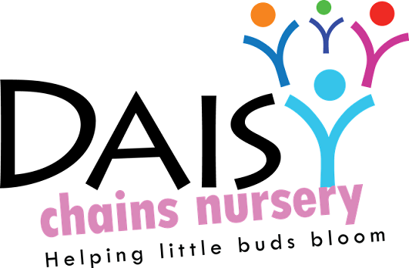
Daisy Chains Nursery
South Ashford Youth Centre
St Stephens Walk
Ashford
Kent
TN23 5BD

Employment

Student/volunteers placements

This is a statutory policy

The Legal framework
- Children Act 2006
- Data Protection Act 1998
- Equality Act 2010
- The Education (Work Experience) Act 1996
- The Health and Safety (Training for Employment) Regulations 1990

Policy statement

This setting recognises that qualifications and training make an important contribution to the quality of the care and education provided by early year’s settings. As part of our commitment to quality, we offer placements to students undertaking early year’s qualifications and training. We also offer placements for school pupils on work experience.

We aim to provide for students on placement with us experiences that contribute to the successful completion of their studies and that provide examples of quality practice in early years care and education.

Methods

We ask that all students wishing to commence a placement with us contact us before they start. For students under the age of 18 years, we obtain their address so that a risk assessment pack and admittance letter is sent to their parent / carers. This risk assessment details all activities and substances that the students may come into contact with. It also asks for emergency consent in the event of an accident and for emergency contact numbers for the student’s relatives. Parent / Carers must sign this form before the student starts.

We provide students and volunteers, at the first session of their placement, with an induction pack on how our groups are managed, appropriate clothing and expectations, how our sessions are organised and our policies and procedures. This induction pack also lays out emergency evacuation procedures as well as a group / student agreement form and confidentiality agreement which the volunteer and student are required to sign, copies are kept on pre-school premises and retained as reference of attendance.

We require students to meet the 'suitable person' requirements of Ofsted and require schools placing students under the age of 17 years with the setting to vouch for their good character. In the case of volunteers, during a face to face interview, we ask for confirmation of identity with photo id and reference before commencing a placement.

We supervise students at all times and do not allow them to have unsupervised access to children. Students who are placed in our setting on a short term basis are not counted in our staffing ratios. However students who are on a longer term placement may be included in our ratios, provided we consider them to be competent.

We take out employers' liability insurance and public liability insurance, which covers both trainees and voluntary helpers.

We co-operate with students' tutors in order to help students to fulfil the requirements of their course of study and require students to keep to and sign our confidentiality policy.
We communicate a positive message to students about the value of qualifications and training.
We make the needs of the children paramount by not admitting volunteers or students in numbers that hinder the essential work of the setting. We ensure that trainees and students placed with us are engaged in bona fide early years training, which provides the necessary background understanding of children's development and activities. We are able to provide appropriate references confirming work as needed for future employers.

This policy was adopted at a meeting:

Held on: 24/08/20

Date to be reviewed: August 2021

Signed on behalf of the management: J Sutton

Name of signatory: James Sutton

Role of signatory (e.g. owner): manager

