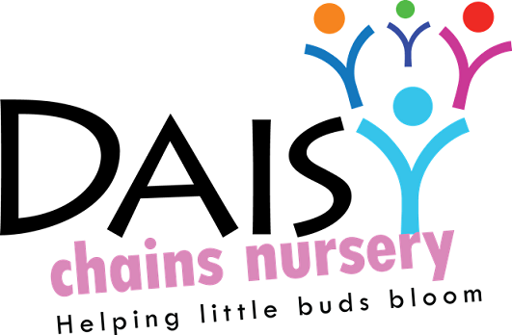
Daisy Chains Nursery
South Ashford Youth Centre
St Stephens Walk
Ashford
Kent
TN23 5BD

Child care practice

The role of the key person and settling-in

This is a non-statutory policy.

Policy statement

We believe that children settle best when they have a key person to relate to, who knows them and their parents well, and who can meet their individual needs. Research shows that a key person approach benefits the child, the parents, the staff and the setting by providing secure relationships in which children thrive, parents have confidence, staff are committed and the setting is a happy and dedicated place to attend or work in.

We want children to feel safe, stimulated and happy in the setting and to feel secure and comfortable with staff. We also want parents to have confidence in both their children's well-being and their role as active partners with the setting.

We aim to make the setting a welcoming place where children settle quickly and easily, because consideration has been given to the individual needs and circumstances of children and their families.

The key person role is set out in the Welfare Requirements of the Early Years Foundation Stage. Each setting must offer a key person for each child.

The procedures set out a model for developing a key person approach that promotes effective and positive relationships for children who are in settings.

Procedures

- We allocate a key person before the child starts.
- The key person is responsible for the induction of the family and for settling the child into our setting.
- The key person offers unconditional regard for the child and is non-judgemental.
- The key person works with the parent to plan and deliver a personalised plan for the child’s well-being, care and leaning.
- The key person acts as the key contact for the parents and has links with other carers involved with the child, such as a childminder, and co-ordinates the sharing of appropriate information about the child’s development with those carers.
- A key person is responsible for developmental records and for sharing information on a regular basis with the child’s parents to keep those records up-to-date, reflecting the full picture of the child in our setting and at home.
- The key person encourages positive relationships between children in her/his key group, spending time with them as a group each day.
- We provide a buddy key person system, so the child and the parents have a key contact in the absence of the child’s key person.
- We promote the role of the key person as the child’s primary carer in our setting, and as the basis for establishing relationships with other staff and children.
- The key person cares, and responds sensitively to a child’s individual feelings, ideas and / or behaviour. This key person supports children with additional needs and works closely with other agencies to ensure inclusion at all times.
- The key person is primarily responsible for personal care routines, e.g. nappy changing, toileting, sleep periods, shared eating times.
- The key person helps the child to become familiar with the setting and to feel confident and safe within it, supporting parents/carers to achieve this.
- The key person supports the child throughout new situations and experiences including times of anxiety or illness that may occur whilst in the setting.
- The allocated Key person is the same person for each sibling in the family whenever possible
- All Key people are employed on a full time basis to ensure consistency and familiarity for both child and parent at arrival and collection times, being available to share information and concerns/news.
- We ensure that the Key Person is there for feeding, sleeping, nappy changing times and comforting times when the child is not feeling very well, they will complete relevant forms as necessary taking on the responsibility in sharing these with parents/carers.
- Our Key person role is proactive in attending transition meetings with the new setting/schools to ensure that all information about the child is passed on to their new provider and to support the parent during this next step in their child’s transition.

Settling-in

- Before a child starts to attend the setting, we use a variety of ways to provide his/her parents with information. These include written information (including our prospectus and policies), displays about activities available within the setting, information days and evenings and individual meetings with parents.
- Before the child is enrolled, we provide opportunities for the child and his/her parents to visit the setting.
- We allocate a key person to each child and his/her family before she/he starts to attend; the key person welcomes and looks after the child and his/her parents at the child's first session and during the settling-in process.
- We may offer a home visit by the person who will be the child's key person, to ensure all relevant information about the child can be made known. (this will include the manager or deputy manager attending your home with the key person to ensure safety to our staff)
- If a home visit is agreed upon we will take this opportunity to complete your child’s registration pack and any other relevant paperwork. This may be done via a zoom video call.
- When a child starts to attend, we explain the process of settling-in with his/her parents and jointly decide on the best way to help the child to settle into the setting.
- Each child is treated as an individual and we cater to all needs. If the child struggles with this settling in period we would discuss the option for the parent to stay for a brief while to support this transition for the child.
- Younger children will take longer to settle in, as will children who have not previously spent time away from home. Children who have had a period of absence may also need their parent to be on hand to re-settle them.
- We consider a child to be settled when they have formed a relationship with their key person; for example the child looks for the key person when he/she arrives, goes to them for comfort, and seems pleased to be with them. The child is also familiar with the environment and is pleased to see other children and participate in activities.
- When parents leave, we ask them to say goodbye to their child and explain that they will be coming back, and when.
- We do not believe that leaving a child to cry will help them to settle any quicker. We believe that a child's distress will prevent them from learning and gaining the best from the setting.
- We reserve the right not to accept a child into the setting without a parent or carer if the child finds it distressing to be left. This is especially the case with very young children.
- Within the first four to six weeks of starting we discuss and work with the child's parents to start to create their child's record of achievement.

This policy was adopted at a meeting:

Held on: 24/08/20

Date to be reviewed: August 2021

Signed on behalf of the management: | J Sutton
Name of signatory: James Sutton

Role of signatory (e.g. owner): manager

