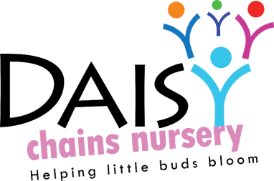
Daisy Chains Nursery,
South Ashford Youth Centre,
St Stephens Walk,
Ashford,
Kent,
TN23 5BD

Anti-Bullying and Harassment / Intimidation Policy.

Daisy Chains Nursery believes that our children and staff have the right to feel safe and protected. We take bullying and harassment very seriously and any form of it will not be tolerated.

We aim to prevent bullying from happening by recognizing that children should be taught a respect for themselves, and for others, at an early age. By teaching the children to act in a particular way with their peers and by the promotion of positive role models by the staff - parents and other adults caring for the children should recognize the importance of showing it at all times.

Bullying behaviour includes:
• Name calling or other mental abuse
• Physical violence
• Threats or intimidation
• Isolating others (whether short or long term) from joining in with group play / meetings / day to day issues.

If a child bullies another child – we adopt the following tactics;
- We intervene to stop the child harming the other child and explain to the child doing the bullying why their behaviour is inappropriate, whilst showing the children who have been bullied, that we are able to listen to their concerns and act upon them.
- We help the child who has bullied to say sorry for their actions, but do not force, whilst remembering that some children do not always understand what saying sorry means.
- We make sure that children who bully, receive praise when they display acceptable behaviour.
- We do not ‘label’ children who bully, but discuss what has happened with their parents and work out with them a plan for handling the child’s behaviour.
- When children have been bullied, we share with their parents and explain that the child who did the bullying is being helped to adopt more acceptable ways of behaviour, whilst maintaining confidentiality for all concerned.
- We recognise that children who bully may be experiencing bullying themselves, or be subject to abuse or other circumstances causing them to express their anger in negative ways towards others

If staff become the targets of bullying behaviour / harassment from others – we adopt the following tactics;
- We talk to both parties to find out facts and reasons and a Manager acts as a go between to try to resolve any issues felt by either party. Written explanations / records will be made.
- We ensure that the children do not suffer any negative feelings within the group.
- Support is given to both parties in order for them to understand how the other person is feeling.
- In some cases of staff continual bullying / harassment at work, we will instigate our disciplinary procedure, if the person involved has not already activated the grievance procedure.
- If a parent is the instigator of inappropriate behaviour, then the parent will be asked not to enter the room where the staff member is working. A Manager will endeavour to investigate any potential cause and to alleviate any concerns felt by both parties. However, in extreme cases this may affect a child’s place within group and we reserve the right to take the place away from a family.

This policy was adopted at a meeting:

Held on: 23/06/20

Date to be reviewed: 23/06/20

Signed on behalf of the management: James Sutton

Name of signatory: James Sutton

Role of signatory (e.g. owner): manager

