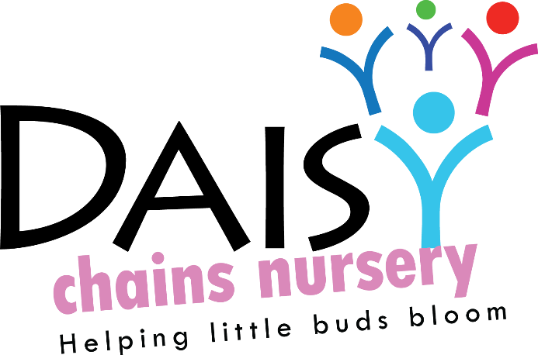
Daisy Chains Nursery,
South Ashford Youth Centre,
St Stephens Walk,
Ashford,
Kent,
TN23 5BD

DATA PROTECTION – children

FAIR PROCESSING NOTICE - DATA PROTECTION ACT 1998

The following departments all process information on children in order to help administer education and children’s services;-

- Pre-schools / Nurseries and Schools;
- Local Authorities (LAs)
- The Secretary of State for Children, Schools and Families
- The Department for Children, Schools and Families (DCSF - the government department which deals with education and children’s services)
- The Qualifications and Curriculum Authority (QCA)
- Her Majesty’s Chief Inspector of Education, Children’s Services and Skills (Ofsted)
- The National Assessment Agency (NAA)

This means, among other things, that the data held about children, must only be used for specific purposes allowed by law. We all have to comply with the Data Protection Act 1998

Daisy Chains Nursery holds information on our children in order to support their development, to monitor their progress and to assess how well we are doing. This information includes contact details, attendance information, characteristics such as ethnic group, special educational needs and any relevant medical information. From time to time we are required to pass on some of this data to Local Authorities, the DCSF and to the QCA and Ofsted.

The Local Authority (LA) uses information about children to carry out specific functions. For example, the Local Authority will make an assessment of any special educational needs the child may have. It also uses information to derive statistics to help them make decisions. The statistics are used in such a way that individual children cannot be identified from them.

The Qualifications and Curriculum Authority uses information about children to administer national assessments such as the Foundation Stage Profile. Any results passed on to the DCSF are used to compile statistics on trends and patterns in levels of development. The QCA uses this information to evaluate the National Curriculum and assessment procedures and to ensure that these are continually improved.

Her Majesty’s Chief Inspector of Education Children’s Services and Skills (Ofsted) do not routinely process any information about individual children. However, whilst Ofsted holds no records of individual children’s progress, it does use information about group achievements to help make judgements about the quality of Education in Pre-schools and Nurseries.
The National Assessment Agency uses information from those groups undertaking the Foundation Stage Profile. It also uses information in working with schools, the QCA, and Awarding Bodies to ensure that an efficient and effective assessment system is delivered nationally.

The Secretary of State for Children, Schools and Families and the Department for Children, Schools and Families (DCSF) use information about children for research and statistical purposes, to allocate funds, to inform, influence and improve education policy and to monitor the performance of the education and children’s services as a whole. The DCSF feedback information to the LAs about children for a variety of purposes. The DCSF may also use contact details from these sources to obtain samples for statistical surveys: these surveys may be carried out by research agencies working under contract to the Department.

The DCSF may also disclose individual child and pupil information to independent researchers into the educational achievements of pupils who have a legitimate need for it for their research, but each case will be determined on its merits and subject to the approval of the Department’s Chief Statistician.

The Children Act 2004 permits the disclosure of information from registered childcare providers for inclusion on ContactPoint. The purposes of ContactPoint are to:-
- Help practitioners working with children quickly identify a child with whom they have contact
- Determine whether that child is getting the services (education / primary health care) to which he or she is entitled
- Enable earlier identification of needs, more effective action to address these needs and
- Encourage better communication and closer working between practitioners
- ContactPoint will hold for each child or young person in England (up to their 18th birthday):
- Basic identifying information: name, address, gender, date of birth and an identifying number
- Name and contact details for a child’s parent or carer
- Contact details for services involved with a child: as a minimum educational setting (e.g. school) and primary medical practitioner (e.g. GP practice) but also other services where appropriate.
- The facility to indicate if a practitioner is a lead professional for a child and/or if an assessment under the Common Assessment Framework has been completed.

ContactPoint will NOT contain any case information (such as case notes, assessments, attendance, exam results, medical records or subjective observations).

Access will be strictly limited to those who need it to do their job. All authorised users must have undergone relevant mandatory training, have security clearance and have a user name, a password, a PIN and a security token to access ContactPoint. To ensure high standards of accuracy, information on ContactPoint will be drawn from a number of existing systems including the termly school Census from which pupil’s home address will be collected.

For further information go to www.everychildmatters.gov.uk/contactpoint

Children, as data subjects, have certain rights under the Data Protection Act 1998, including a general right of access to personal data held on them, with parents exercising this right on their behalf if they are too young to do so themselves. If you wish to access the personal data held about your child, please contact the relevant organisation in writing:

- Your child’s pre-school (Daisy Chains Nursery) at their individual address;
- The Local Authority at: Access to Information Co-ordinator, Room 2.35 Sessions House, County Hall, Maidstone, ME14 1XQ;
- The QCA’s Data Protection Officer at QCA, 83 Piccadilly, LONDON, W1J 8QA;
- Ofsted’s Data Protection Officer at Alexandra House, 33 Kingsway, London WC2B 6SE;
- The National Assessment Agency Data Protection Officer at 29 Bolton Street, London W1J 8BT;
- The DCSF’s Data Protection Officer at DCSF, Sanctuary Buildings, LONDON, SW1P 3BT.

In order to fulfil their responsibilities under the Act the organisation may, before responding to this request, seek proof of the requestor’s identity and any further information required to locate the personal

