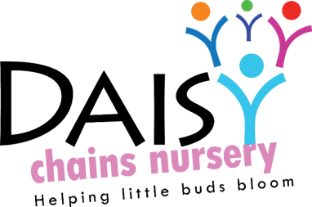
Daisy Chains Nursery,
South Ashford Youth Centre,
St Stephens Walk,
Ashford,
Kent,
TN23 5BD

Early Years Entitlement Funding

Free entitlement hours are available to children in the term following their second or third birthdays, in accordance with the KCC eligibility criteria, which can be found on www.kent.gov.uk. These funded sessions are available between the hours of 9.30am-3.30pm, by way of morning sessions, afternoon session or all day sessions, based on availability.

Any extra additional sessions will be invoiced at the rate stated in the admissions and pricing policy.

It is the parent/carer responsibility to ensure that the following is abided by, if the child attends two groups. KCC will apportion the funding between a maximum of two groups. However, this does not mean that you have to be offered all of these hours with one group. The funding can be shared between any registered nursery (or some child-minders) in Kent.

Parent/carer are asked to choose (and check) which sessions they would like to claim from our available funded sessions. Session cannot be changed midterm. Sessions can only be changed at the end of a term, ready for the upcoming new term; if available. If a child transfers to another nursery midterm, their funding may be transferred to the new nursery based on our discretion, assessing each case individually.

Funded hours will be ‘free at the point of Access’ and so no other charges will be demanded from families who chose not (or are unable) to claim above their maximum hours a week. However late fees, for those families who pick up their child late, will still be charged in accordance with KCC’s funding policy.

Daisy Chains Nursery must see the child’s birth certificate on registration. Without a birth certificate a child cannot start as this proves their actual legal age.

Parents have to agree to use the session booked on a regular basis and children have to attend. Parents are claiming Government funding through Daisy Chains Nursery, we have to produce legal registers for the funding department to prove that children actually attend. This Early Years entitlement statement is in addition to our fee paying statement and policy.

The information collected will be held by Daisy Chains Nursery in paper form. It is also collected by Kent County Council in electronic form and will be compared to data from other providers and school. Both of these formats are stored in compliance with GDPR.
Date to be reviewed: 5th May 2020

Signed on behalf of the management:
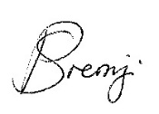
Name of signatory: Sajedah Mohamedali

Role of signatory (e.g. owner): Director

