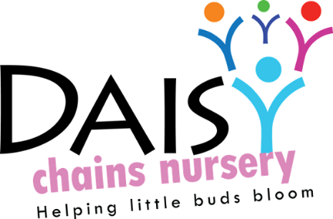
Daisy Chains Nursery
South Ashford Youth Centre
St Stephens Walk
Ashford
Kent
TN23 5BD

Outdoor Policy

Daisy Chains Nursery recognises and promotes the importance of outdoor play to promote:
- Children’s physical development,
- resiliency,
- taking manageable risks
- and to improve the well-being and involvement of each individual child.

We aim to promote all the aspects that are available inside, into the outdoor environment. Therefore we will encourage children’s creativity, fine motor as well as gross motor skills in a variety of ways through adult led and child let activities. We allow children the time to engage within their natural environment and offer different resources to promote learning through play.

We plan to engage in the outside area in all weathers and through substantial amounts of time within sessions. We will encourage them to ensure their child is appropriately dressed with items such as wellie boots, gloves, hats and scarves. We believe that it is important for children to engage in this environment and experience all forms of weather and the changing seasons on a first hand basis.

When partaking in these sessions, we ensure health and safety measures are taken as well as safeguarding children (see separate policies). These aspects would include:
- an extensive risk assessment carried out by a member of staff before each
- We will ensure that a qualified first aider is always present when in the outside area.
- In the event of a child going missing an extensive search will be carried out by a member of staff and all other children will be kept safe inside. If the child is not found then the correct emergency services will be contacted as well as the parent/carer (please see missing child policy for full details)
- When outside staff will be positioned appropriately
- In cases of extreme weather to ensure the safety and well-being of all, we would not enter the outside area if it would be considered a health and safety issue.

This policy was adopted at a meeting:

Held on: 24/08/20

Date to be reviewed: August 2021

Signed on behalf of the management: J Sutton

Name of signatory: James Sutton

Role of signatory (e.g. owner): manager

