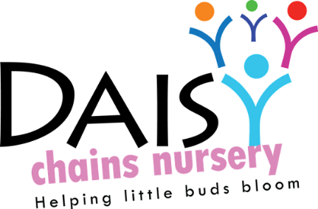
Daisy Chains Nursery
South Ashford Youth Centre
St Stephens Walk
Ashford
Kent
TN23 5BD

Two year old Policy and procedure
Aims
Daisy Chains Nursery aim to provide an environment in which all children are supported to reach their full potential. We understand that observation and assessment plays an important part in helping parents, carers and practitioners to recognise children’s progress, understand their needs, and to plan activities and support.

In accordance with the Early Years Foundation Stage (EYFS) 2012, the company reviews individual children’s progress between the ages of two and three. This is referred to as the Progress check at age 2. The company has put into place clear strategies to ensure any concerns are addressed and practice is differentiated to support the child within the setting

How we implement the Progress Check at 2
The Key person has a meeting with the parents and carers to discuss their child’s progress; this is usually carried out in the term before the child’s 3rd birthday. Our Progress Check form identifies the child’s strengths and any areas where the child’s progress is less than expected. If there are significant emerging concerns, or an identified special educational need or disability then the key person will work with the SENCO and parent to develop a targeted plan to support the child’s future leaning and development involving other professionals as appropriate.

During the meeting with Parents and carers to discuss the Progress check at 2 the key person will show observations detailing the child’s interests, achievement and actions within each of the prime areas within the pre-school environment. This will take account of the child’s view and comments that they may have made. The parent and carers will then share information about their child at home and together both key person and parent will identify agreed learning priorities and support learning at home.
This completed Progress Check at 2 is then shared with the Health Visiting team, with parental permission and forms a part of the Healthy Child Check.

The Progress Check at 2 also forms an important part of the summative assessment process carried out by the key person on a regular basis and collated within the Child’s Unique Learning Journal

This policy was adopted at a meeting:

Held on: 24/08/20

Date to be reviewed: August 2021

Signed on behalf of the management: J Sutton

Name of signatory: James Sutton

Role of signatory (e.g. owner): manager

