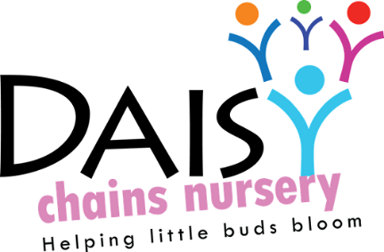
Daisy Chains Nursery
South Ashford Youth Centre
St Stephens Walk
Ashford
Kent
TN23 5BD

Research on Ethics Policy

Non Statutory Policy

Legislation: Data protection Act (1989), Equality Act (2010), Childcare Act (2006) United Nations Convention on the Rights of the Child (UNCRC, 1989)

Aim

At Daisy Chains Nursery we recognise the importance and promote continued professional development. We understand that students or staff members undertaking a qualification may need to undertake observations through written forms or photographs as well as research projects. We aim to encourage this, but set procedures and ethical guidelines must be adhered to. (See safeguarding, data protection and student/volunteer polices)

Procedures

We understand the importance of staff members or students/volunteers furthering their personal development and obtaining qualifications with us, although we would never obstruct a staff/students chance to continue their professional development, the following procedures and ethical guidelines must be strictly adhered to:
- Parents/carers must have given written consent and have full knowledge and understanding of the procedures and purpose of the research/observations to be carried out
- the child must be informed and happy to be observed
- the child must not be coerced into participation
- children are not to be exposed to mental or physical stress
- the child must not have their privacy invaded
- children must be treated fairly with consideration and respect
- no names must recorded and all participants must remain anonymous
- any relevant findings/results must be shared with the parents/carers
- If photos are being taken, separate consent must be given if not included in the initial consent. These may only consist of children hands or back of heads to ensure safeguarding is maintained at all times
- All records must be kept confidential and be stored in the safe on the premises, unless it is required to be taken out of the setting as a requirement of the course. In this case parents/carers must sign a disclaimer allowing a copy of observations (written or photographs) for study purposes to be released.
- Management will always check any documentation that is to be taken off site and Chains Nursery will also keep a copy in the child’s individual file.
- An inclusive nature must be taken when choosing participants and must be aware of the Equality Act (2010). (please see our equality and diversity policy)
- If questionnaires are to be carried out then questions must be worded carefully to ensure respect that it is easy to understand, short and not to ask for money.

Procedures for informed consent:

- parents and children must understand the purpose of the research and why they have been asked to take part
- they will be informed how they fit into the research as a whole
- they must understand what they will be doing
- what the activity is (if applicable)
- name method of observation i.e. questionnaire/written observation
- all participants must remain anonymous
- parents/children may withdraw from the observation/research/activity at any time
- it must state where the data will be stored and what it will be used for

Although children may not be able to verbally withdraw consent, this should be recognised if any of the following are present:
- refuses to engage with the researcher
- becoming abnormally quiet
- crying, becoming distressed or turning away
- refusing to engage with any materials

Further Reading:

- Mukherji P, Albon D (2010) Research Methods in Early Childhood. Sage Publications. London
- Roberts-Holmes G (2005) Doing your early years research project. Sage Publications. London

This policy was adopted at a meeting:

Held on: 24/08/20

Date to be reviewed: August 2021

Signed on behalf of the management: J Sutton

Name of signatory: James Sutton

Role of signatory (e.g. owner): manager

