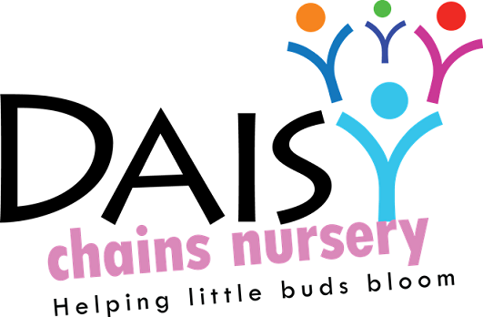
Daisy Chains Nursery
South Ashford Youth Centre
St Stephens Walk
Ashford
Kent
TN23 5BD

Sick Children / Adults Policy

Links to statutory framework:

Daisy Chains Nursery take positive steps to prevent the spread of infection throughout the buildings through regular hygiene awareness training of staff; daily, weekly and termly cleaning of all equipment and training on first aid for the staff.

In the event of children becoming ill during the session, the key person will endeavour to contact one of the emergency contact adults for the sick child, through the Registration Form telephone numbers. Once contacted, the adult will be expected to make arrangements to collect the sick child before the end of the session. Until the child is collected, the Key person will remain with them in the rest area / book area away from the other children, in order to prevent the spread of infection.

We will not accept sick children into the group environment until they recover fully from their illness. Parent/carers are requested that if a child has diarrhoea and / or sickness that the child is free from it for at least 48 hours from the last episode (unless it is due to a medical condition; ie coeliac disease).

In the case of infectious diseases / conditions (chicken pox, rubella, measles, conjunctivitis etc), the parent/carers should seek advice from their General Practitioner and staff before letting their child to return to the sessions. This is most important as the ages of our children are such that they may not have built up a resistance against certain illnesses or are of weakened immunity.

There is a book, at group, published by the Kent Public Health Protection Agency in Maidstone called “Communicable and Infectious Diseases”. It is by these suggested criteria that we take advice.

In the event of a staff member becoming ill during the session, then they will be sent home (either on their own or contacting someone via their emergency contact forms). If this affects the adult to children ratio, steps will be taken to get emergency cover for the staff via the emergency staff cover form.

If a child belonging to a staff member is ill or becomes ill whilst at school – then the child will not be allowed to come into the sessions with their parent – alternative arrangements will have to be sought.

Ofsted will be informed, by letter, as well as the Public Health Protection Agency in Maidstone, when a child presents with a communicable disease at group. This could be Meningitis or an outbreak of Impetigo.

This policy was adopted at a meeting:

Held on: 24/08/20

Date to be reviewed: August 2021

Signed on behalf of the management: J Sutton

Name of signatory: James Sutton

Role of signatory (e.g. owner): manager

